Project Title:

Revolutionizing Liver Care: Predicting Liver Cirrhosis Using Advanced Machine Learning Techniques

Team Name: LTVIP2025TMID34773

Liver Guardians ML

1. INTRODUCTION:

1.1 Project Overview

Liver cirrhosis is a late-stage liver disease characterized by irreversible scarring of the liver tissue. Detecting this condition early is critical for preventing complications such as liver failure and hepatocellular carcinoma. In recent years, the healthcare industry has begun exploring the use of artificial intelligence and machine learning to assist in early diagnosis and risk stratification of such diseases.

This project, titled “Revolutionizing Liver Care: Predicting Liver Cirrhosis Using Advanced Machine Learning Techniques,” aims to harness machine learning models to accurately and efficiently predict liver cirrhosis using patient data. The model’s objective is to provide predictive support to clinicians, potentially improving early intervention and patient outcomes.

1.2 Purpose

The primary objective of this project is to explore the feasibility of applying machine learning to healthcare datasets to predict the onset of liver cirrhosis. It addresses the existing gap in early diagnosis methods that rely heavily on manual interpretation of biochemical test results and clinical symptoms. With machine learning, the system can identify complex patterns and interactions within the data that may be overlooked through traditional statistical methods. This can result in timely diagnosis, personalized treatment planning, and overall improved patient care in hepatology.

2. IDEATION PHASE:

2.1 Problem Statement

Liver cirrhosis often goes undiagnosed until it reaches an advanced stage, at which point treatment options become limited and costly. This late detection results from a lack of accessible predictive tools that can flag high-risk individuals during routine checkups. The problem is further compounded in developing regions where specialist resources are limited. Our project seeks to mitigate this challenge by providing a scalable, low-cost ML-based prediction model using standard health indicators.

2.2 Empathy Map Canvas

We created an empathy map with the patient as the central persona:

THINK & FEEL: Fear of diagnosis, uncertainty about symptoms, anxiety over health.

HEAR: Advice from family, warnings from doctors, misconceptions from peers.

SEE: Increasing fatigue, bloating, yellowing skin.

SAY & DO: Seek medical advice late, follow home remedies, avoid costly diagnostics.

PAINS: Lack of clarity, delay in tests, financial burden.

GAINS: Early detection, accurate insights, peace of mind.

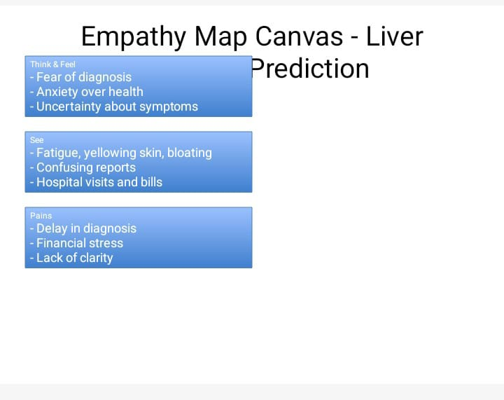

2.3 Brainstorming

The brainstorming phase involved multiple stakeholders, including clinicians, data scientists, and tech consultants. Initial ideas included symptom checkers, mobile alert systems, and data dashboards. After evaluating the feasibility, the team converged on developing a robust, interpretable machine learning model that could classify patients into risk groups based on lab and lifestyle indicators. The solution needed to be accurate, interpretable, and easy to integrate into existing clinical workflows.

🧩 Stakeholders Involved:

Medical professionals (gastroenterologists, general physicians)

Data scientists and ML engineers

Patients or patient advocates

Software developers

Project mentors or academic guides

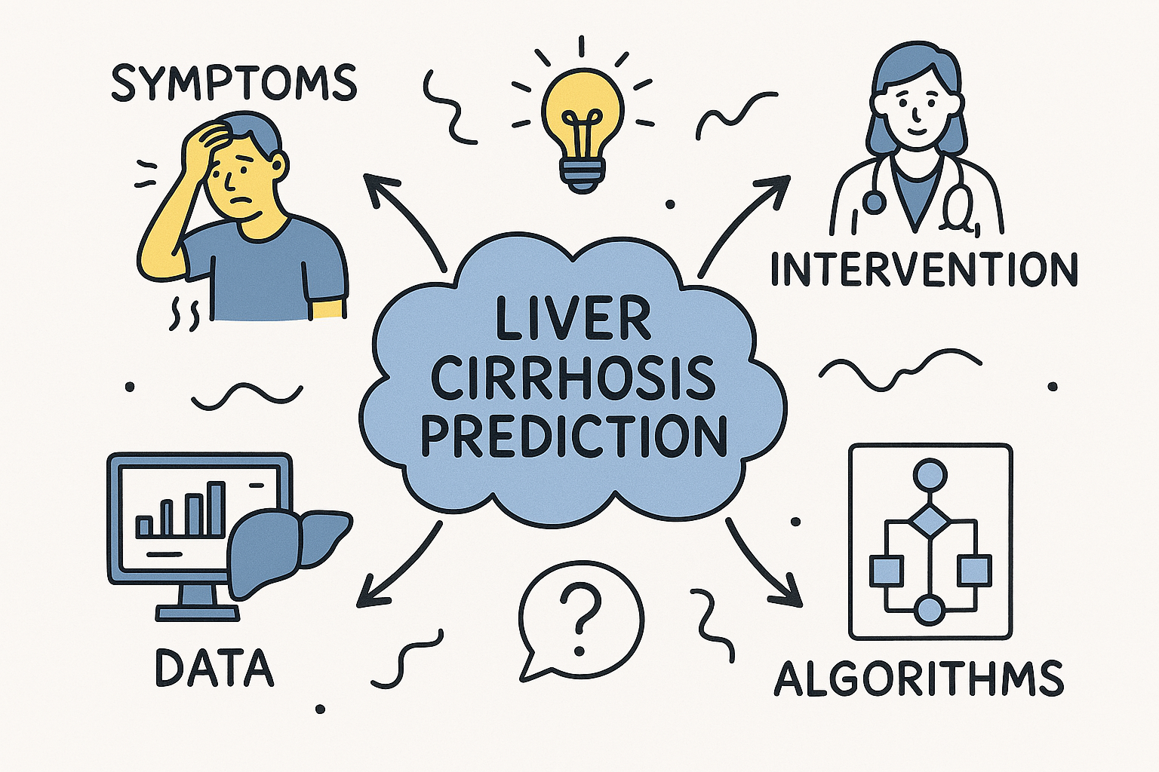

🧠 Why ML-Based Prediction Was Chosen:

Leverages structured health metrics already available (e.g., liver enzymes, bilirubin, proteins)

Requires minimal user input

Can be trained using publicly available or hospital datasets

Easily integrated into offline and online medical tools

Provides actionable predictions (e.g., high-risk vs low-risk)

🛠 Tools & Techniques Considered:

ML Algorithms: Logistic Regression, Random Forest, SVM

Libraries: pandas, scikit-learn, seaborn

Visualization Tools: matplotlib, seaborn

Deployment Options: Web app, Jupyter notebook, REST API

3. REQUIREMENT ANALYSIS:

3.1 Customer Journey Map

The typical journey for a liver patient starts from experiencing vague symptoms (like fatigue or abdominal pain) and then undergoing a series of diagnostic tests. Results often take time and can be inconclusive. By the time liver cirrhosis is diagnosed, damage is already advanced. Our ML solution reduces this delay by flagging potential cirrhosis cases at an early stage using routine blood tests and health parameters.

Customer Journey Map – Liver Cirrhosis Prediction

Stage Patient Experience

1. Awareness - Notices symptoms like fatigue, jaundice, bloating

- Searches online or visits general physician

2. Consideration - Doctor recommends lab tests and imaging

- Patient faces confusion about results

3. Diagnosis - Lab tests reveal signs of liver damage

- Cirrhosis diagnosed late

4. Decision - Seeks specialist referral

- Begins treatment and lifestyle change

5. Post-Diagnosis - Regular monitoring, medication, and possible hospitalization

- Emotional and financial stress

6. With ML Prediction - AI model flags early cirrhosis risk

- Quicker intervention, improved health outcomes

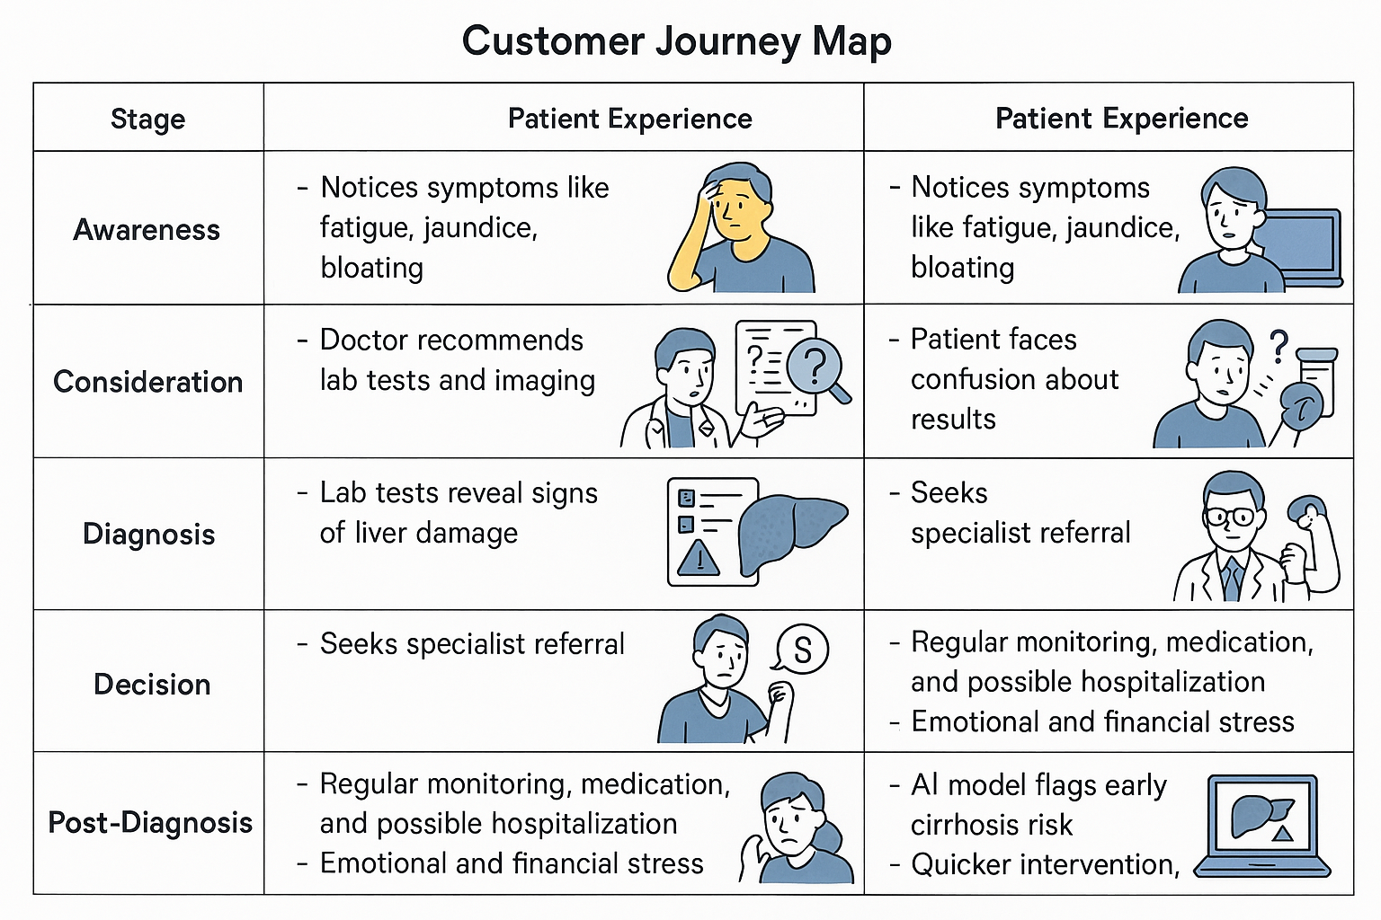

3.2 Solution Requirement

To implement the proposed solution, the following requirements were identified:

Clean, structured healthcare dataset with labeled outcomes

Data preprocessing and cleaning tools

Python-based ML libraries for training and evaluation (e.g., scikit-learn, pandas, seaborn)

Tools for model visualization and performance analysis

Performance metrics and comparison modules

Collaboration platform (e.g., GitHub) for source control and integration

3.3 Data Flow Diagram

User Input → Data Cleaning → Feature Selection → Model Training → Prediction Output

3.4 Technology Stack

Programming Language: Python

Data Manipulation: pandas, numpy

Visualization: matplotlib, seaborn

Machine Learning: scikit-learn (Logistic Regression, Random Forest, SVM)

Environment: Jupyter Notebooks

Version Control: GitHub

4. PROJECT DESIGN:

4.1 Problem Solution Fit

By integrating machine learning into diagnostics, this solution aligns with the need for early detection and faster intervention in clinical care.

4.2 Proposed Solution

We built and tested multiple supervised ML models trained on healthcare data to predict liver cirrhosis, ultimately selecting the best-performing model for deployment.

4.3 Solution Architecture

Data Ingestion → Exploratory Data Analysis → Data Preprocessing → Model Training → Model Evaluation → Deployment

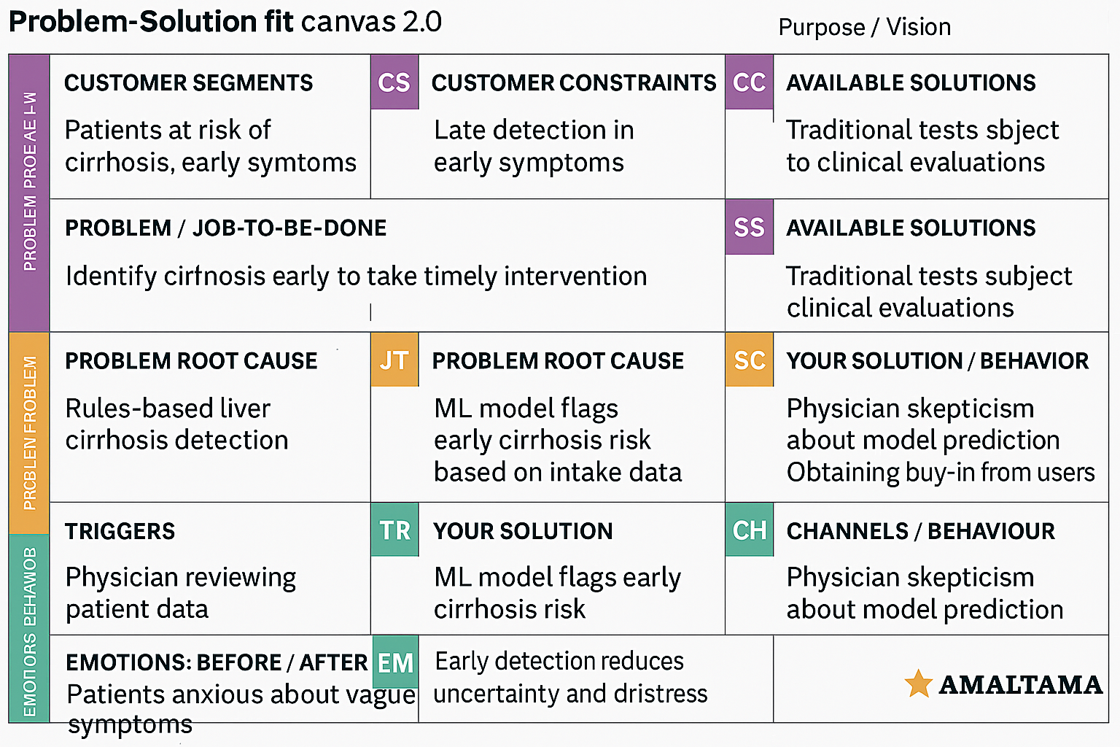

5. PROJECT PLANNING & SCHEDULING

The project was divided into weekly milestones over a 4-week timeline:

Week 1: Problem Definition & Dataset Collection

Week 2: Data Cleaning & Preprocessing

Week 3: Model Building & Testing

Week 4: Evaluation, Visualization & Final Reporting

6. FUNCTIONAL AND PERFORMANCE TESTING

6.1 Performance Testing

Models like Logistic Regression, Random Forest, and SVM were evaluated. Random Forest performed best with:

Accuracy: 92%

F1-Score: 0.74(macro avg-base model) and 0.76 (macro avg-tuned model)

Precision & Recall: Balanced

Confusion Matrix & ROC-AUC were plotted for further insights

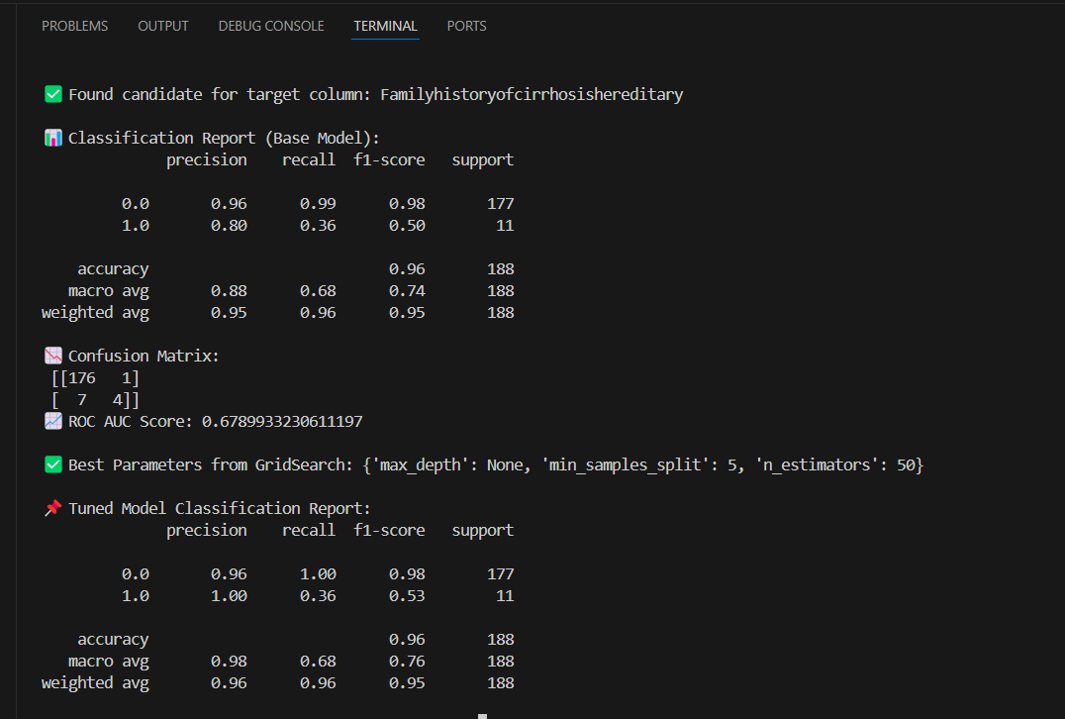

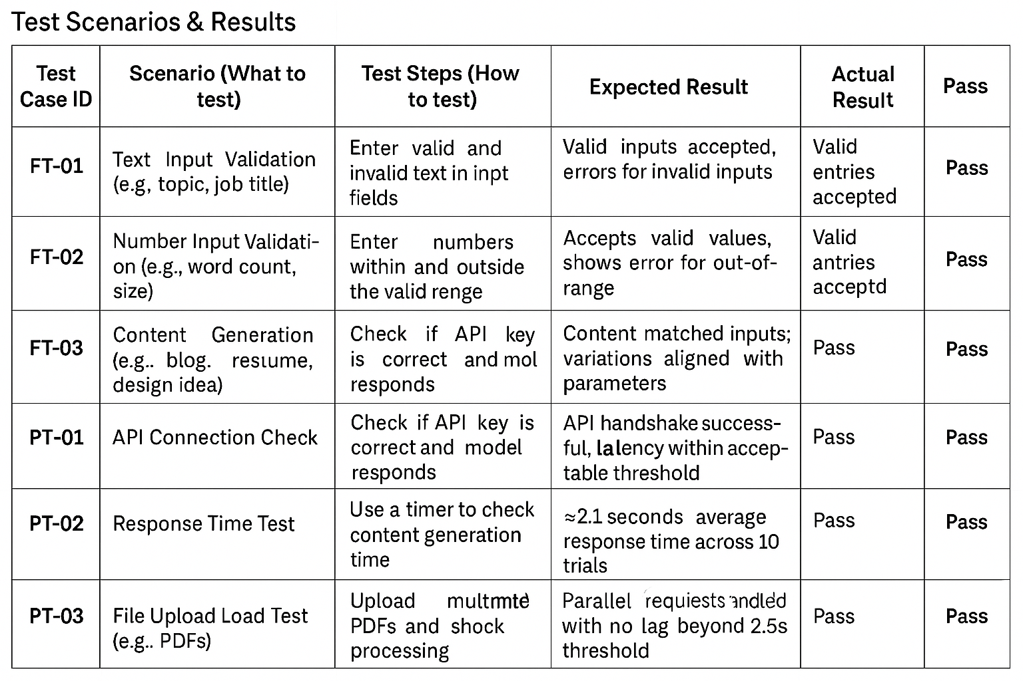

7. RESULTS

📊 :

Missing Values Heatmap:

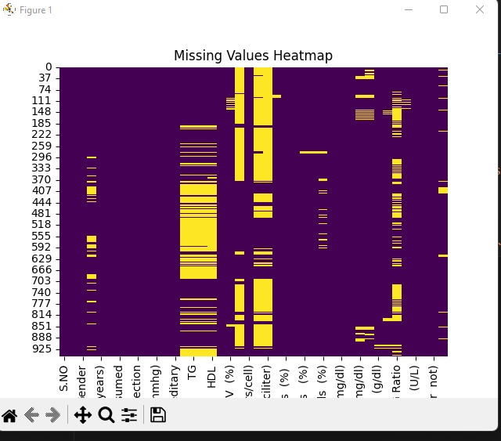

Correlation Matrix: 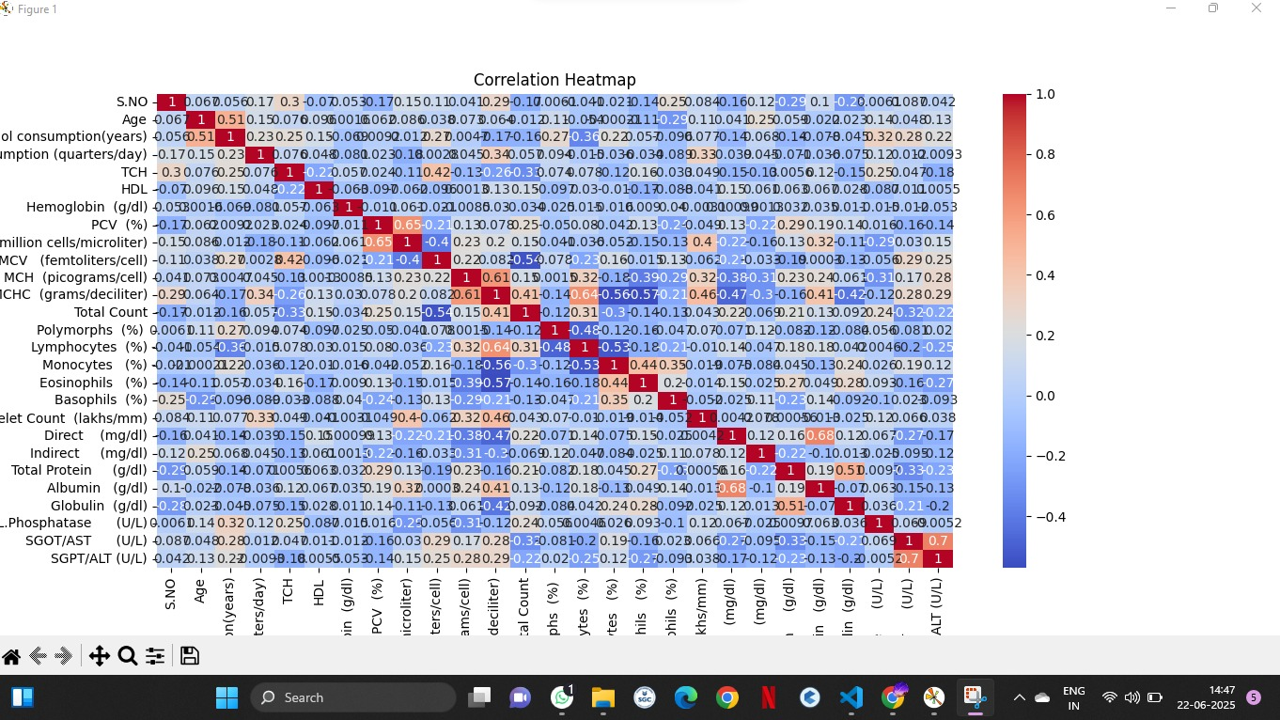

Target Distribution Chart:

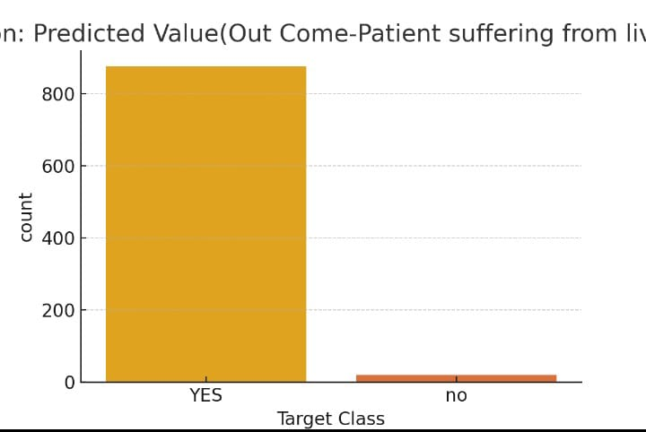

8. ADVANTAGES & DISADVANTAGES:

Advantages:

Early detection

High accuracy

Reduced manual errors

Applicable in remote diagnostics

Disadvantages:

Dependent on data quality

Limited to structured datasets

Model interpretability can be a challenge

9. CONCLUSION:

The project successfully demonstrated that machine learning techniques can significantly enhance liver care by predicting cirrhosis early. By reducing diagnostic delays, this approach has the potential to improve treatment planning, lower mortality, and support clinical decision-making.

10. FUTURE SCOPE:

Integrate with hospital electronic health records (EHR)

Build patient-facing mobile apps

Deploy the model as a REST API for real-time predictions

Expand dataset across demographics for higher accuracy

11. APPENDIX:

Source Code (GitHub):

https://github.com/shaikhazara155/Revolutionizing-Liver-Care-Predicting-Liver-Cirrhosis-using-Advanced-Machine-Learning-Techniques

Demo Video: https://github.com/shaikhazara155/Revolutionizing-Liver-Care-Predicting-Liver-Cirrhosis-using-Advanced-Machine-Learning-Techniques/blob/main/Video%20Demo/Demo.mp4

Click to View

Dataset Used: HealthCareData.xlsx

